**Electronic Signature Option - Instructions for Parents**

Beginning in the 2017-2018 school year, parents have the option to electronically sign certain forms instead of submitting signed paper copies to their child’s school.

Parents will have the option of electronically signing the following forms:

* Media Release Form
* Network/Internet Acceptable Use Agreement
* Directory Information Opt-Out Letter
* Parent and Student Acknowledgement of Student Code of Conduct

Electronic submission of these forms will be available as of August 1, 2017 through our Student Reservation System.

[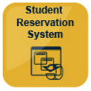](https://reservation.pcsb.org)The Student Reservation System is accessible through the district website [www.pcsb.org](http://www.pcsb.org) by selecting the *Registration* tab at the top and then selecting the *Student Reservation System button.* The system can also be accessed at [https://reservation.pcsb.org](https://reservation.pcsb.org/).

Please follow the steps below to submit your student forms. *See screenshots below for details*.

1. Log in using your user name (**P.xxxx** account) and password.
2. Select the option that describes your child’s enrollment status.
3. Select “**PCS Forms**.”
4. Follow the online instructions to submit applicable student forms*.

*Note: The Parent and Student Acknowledgement and Directory Information Opt-Out forms are applicable to the school year in which they are signed. The Network/Internet Acceptable Use Agreement and Media Release forms, once signed, are active the entire time your child is enrolled in Pinellas County Schools and do not need to be re-submitted each school year.

1. **Log in using your user name (P.xxxx account) and password.**

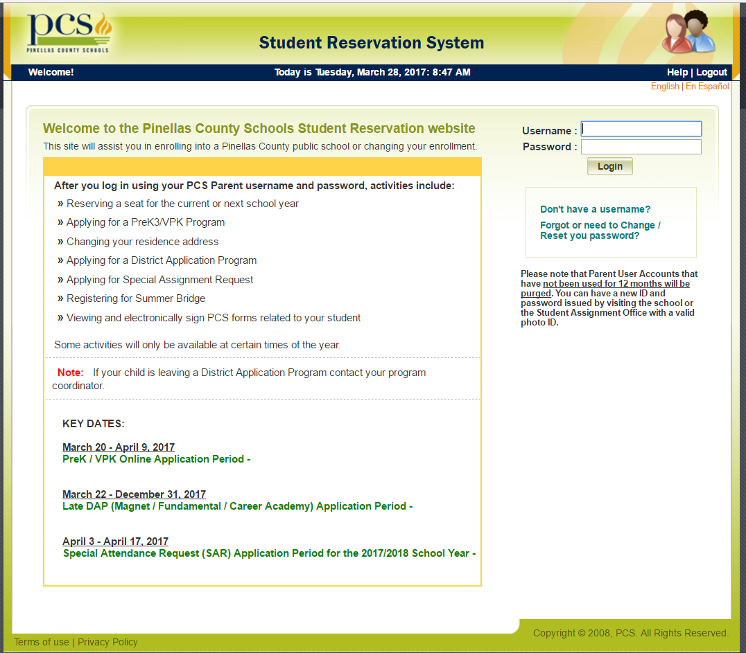

1. **Select the option that describes your child’s enrollment status**

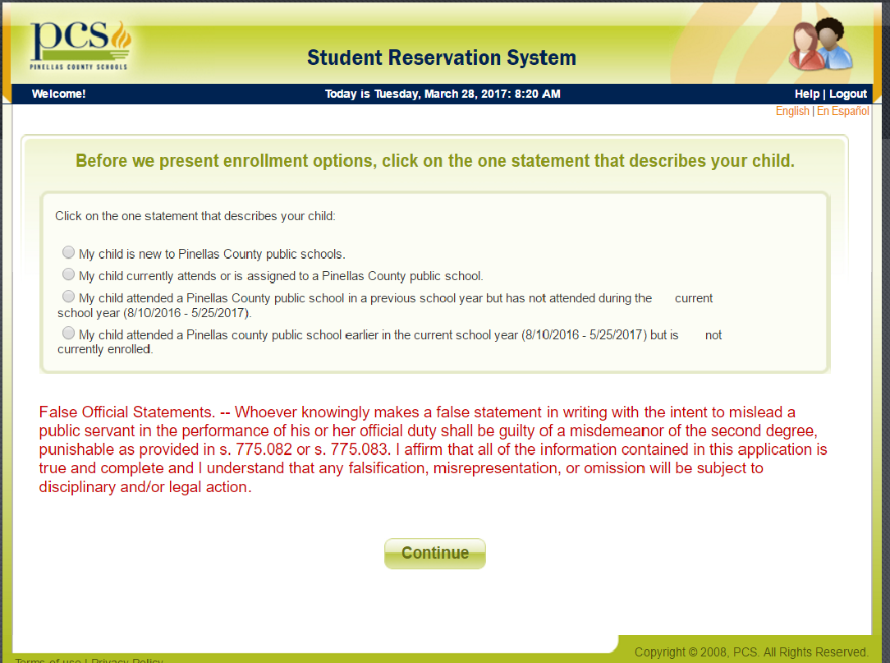

**Select “PCS Forms.”**

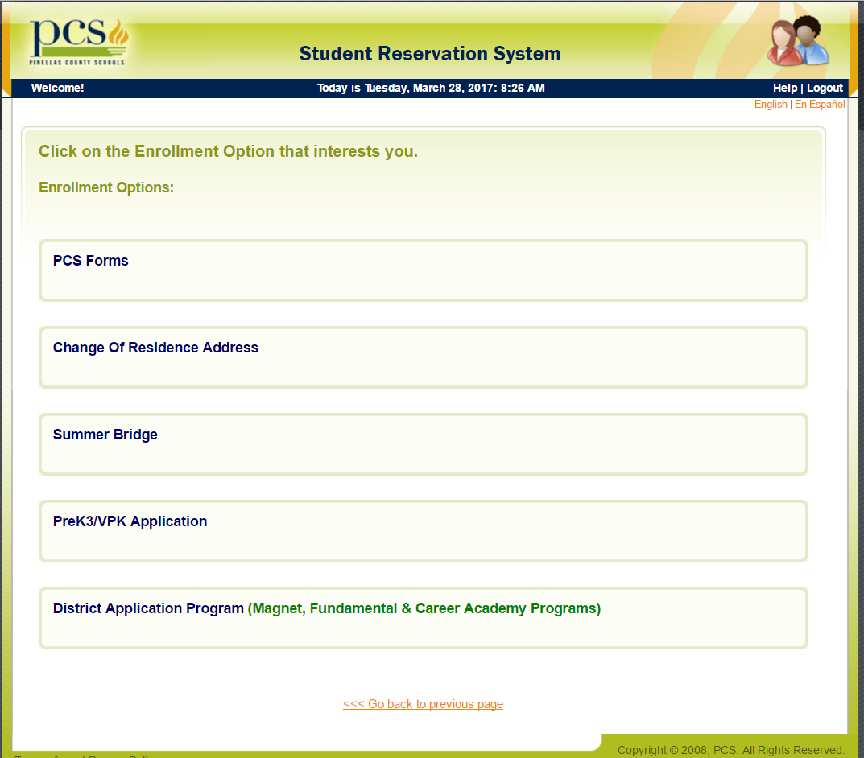

1. **Follow the online instructions to submit your student forms**

